Today we will know all about the richest man and also world's most powerful CEO in the world and will learn all about the Case Study of Amazon Online Shopping Business  Model.

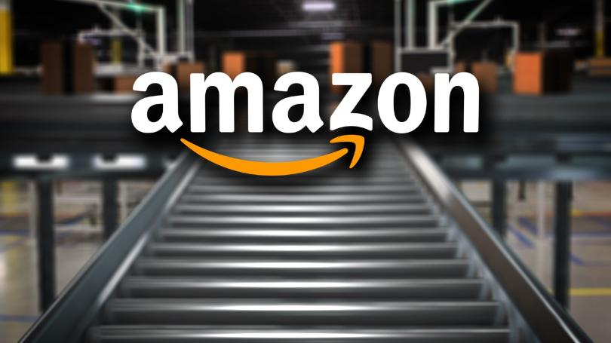

Before learning Case Study on Amazon, we will look up on Amazon's Owner Short Life Story and his ideas and decisions to make his company the world's most popular Online Shopping Site.

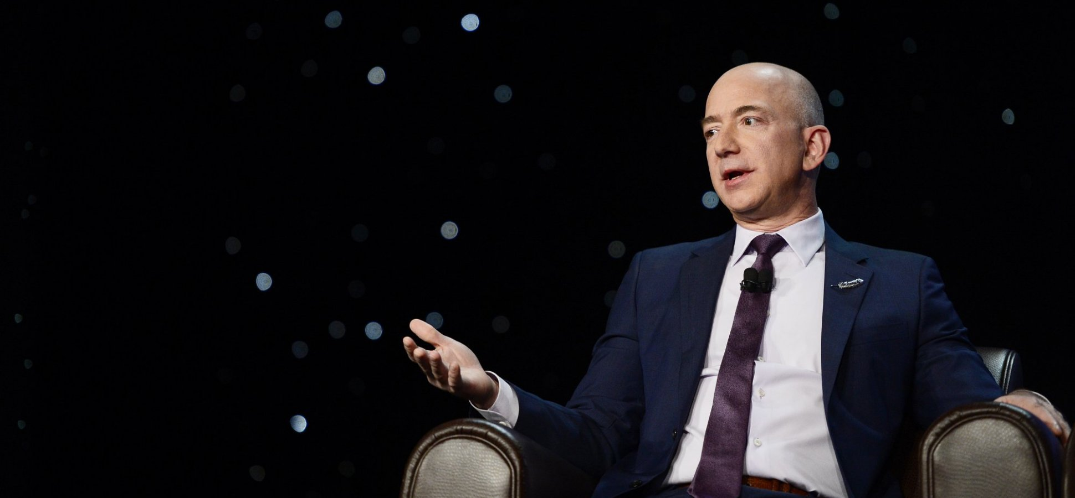

The full name of Amazon Boss' is **Jeffrey Preston Bezos**and he was born January 12, 1964 and when he was born, his mother age was just 16 who was studying in the school but Jeff at very early little age started studying.

At very young age, he became the Vice President of Merchant Banking Company in 1990. But when he thought about the internet boom is the future, he suddenly resigned as Vice President his job because job can be done if he fails in internet business. He startup the company which was named as Amazon from the name of most popular south American river.He started selling books on internet and this book selling company had ousted their IPO in 1997 which was not good enough at startup.This company were from those who survive the .com domain crisis in 2000 among with Sandisk, eBay,Adobe, IBM. As time passes, Amazon also growed by adding different types of products along with books.

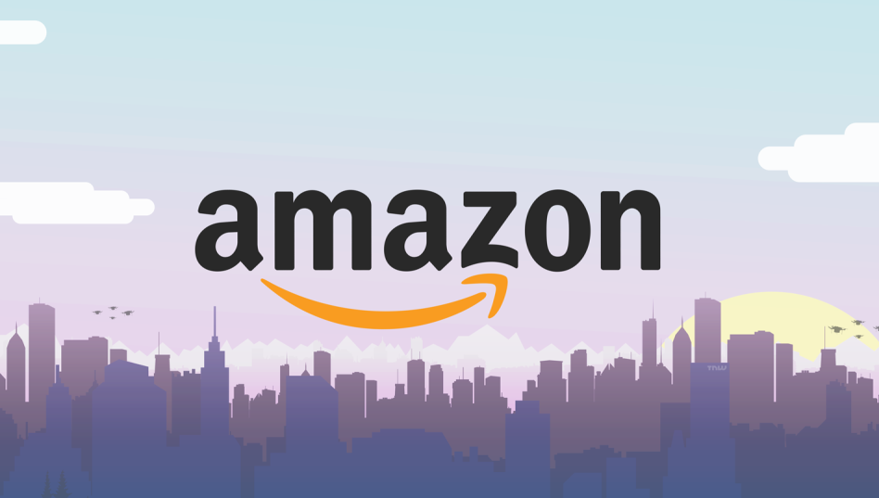

As we know, Amazon is the largest Online Sales Company in the world and from this Jeff Bezos became the world's richest person. Now, Jeff has a personal Net Worth of  $112 Billions which is more than the group of 125 countries GDP. How a man can be so smart and clever that had started from a small garage to the world's giant company.

So, Today we will discuss about how Jeff Bezos became the world's richest person from the zero to hero.

Actually Jeff Bezos always build timely good products, he timely purchased the new companies,timely invested in companies from own money and purchased its own, So it is a big reasons that the personal Net Worth of Jeff Bezos has been increasing suddenly and uniformly.

Jeff Bezos personally invested on the companies like:

* Google
* UBER
* Business Insider
* Twitter
* Workday
* Grail
* Lookout.

Amazon Company' investment was on :

* Homegrocer.com
* Bankbazzar
* Easybar
* Wine.com

Companies Purchased by Amazon are:

[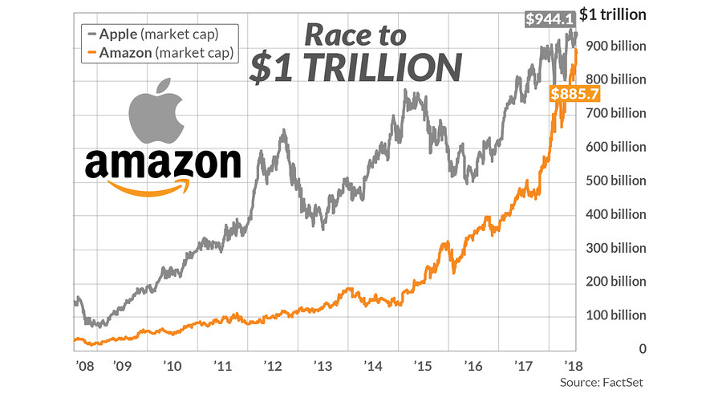](https://ei.marketwatch.com/Multimedia/2018/07/19/Photos/ZH/MW-GM819_amzn_a_20180719131518_ZH.jpg?uuid=4f4b7a6c-8b77-11e8-9b0f-ac162d7bc1f7)

* Wholefoods
* twitch
* audible
* Zappos.com
* IMDb
* The Washington Post
* Goodreads.

Due to above reasons Amazon catch up the growth in the world which can be seen in below graph.

From here, Amazon became the second most company in Market Value Capitalization after Apple.

The Service's provided by Amazon are:

* Amazon.com
* Amazon Prime
* Amazon Consumer Electronics
* Amazon game studio
* Amazon Video
* Amazon Music
* Amazon go
* Amazon Kindle
* Amazon Web Services
* Amazon Wireless.

There are 10 very important points are to be discussed which reflects all about the case study on amazon. If you doesnot understand then read twice or more because it is important and if you are on start as an entrepreneur because somehow what is strategy, mindset and thought process is there which will be discussed below.

* **Customer is The King and I am The Servant.**

Jeff always treated their customers as a king. He always treated customers like a king.

He always focused on The Things Customers Like Most and Customers Dislikes Most.Every Company focused on Customers Likes but never focused on Customers Dislikes.

 The three most things that Customers Dislikes are:

1. DELAY
2. DEFECT
3. OUT OF STOCK

Late Delivery is hated by any Customers. Defect Product is results any Business Model to lay down and Out Of Stock is most hated by Customers. Remember, Customers are not your audience, their attention span will always be small and if website delays for 0.1 second than it is chance to lose 1% Costumers from your hand. So, if website takes 10 second to load then it is chance to lose 100% Customers from your hand.

* **Except More From Your Employees.**

Jeff always excepted more and most from his employees because his 5 lakhs employees has to be take care for 16 crores Customers because they are Servant and Customers are King. This is reason behind the Amazon to be most popular for same day delivery of product.

* **Long Term Vision.**

when investors started invested on amazon, they always expected profit from that but Jeff always answered them that his vision is not for sudden profit or benefit, his vision is for long term profit.

*"OUR VISION IS TO USE THIS PLATFORM TO BUILD EARTH'S MOST CUSTOMERS CENTRIC COMPANY. A PLACE WHERE CUSTOMERS CAN CAME TO FIND AND DISCOVER ANYTHING AND EVERYTHING THEY MIGHT TO BUY ONLINE.*"

                                                                                                       -JEFF BEZOS

* **Complexify the Simple and Simplify the Complex.**

There are two types of entrepreneur, one who those like Mark Zuckerberg and Steve Jobs which explaines all complex things into simplify from so everybody can understand easily.

Anothers are those who are thinking to explain some out of box but they complexify the simple one. Due to these reasons they fails on Product Realise on sometimes and doesnot get any response from Customers.This shows lack Clarity in there Products and Quality.

* **Every Employee has a Hidden Owner.**

Jeff always keep his employee as an Owner which takes care of his Customers. This results in Company Accuracy and Speed.He believes in Create An Owner from Every Employee.Because he does not want any servant in his company but he wants those who runs the Company.

* **Make Quick Decisions from 70% Information.**

Jeff always told, not to collect 80-90% for implementing any decisions. If there is only 70% information is available then starts implementing it and review the Market Response on Products and starts it in quick time because if you take a while for implementing then it will be so late for you to create Entry Barrier in the market. Jeff had done it, and biggest example is Amazon Prime. When project for Amazon Prime was thought, it started after 111 days from thinking day of that. As a result, on first launch it was flopped but after quick response and quick decisions, it updated day by day and present result it is proof.

"FIRST PRODUCT IS NEVER THE FINAL PRODUCT"

* **Value Imitation Vs Value Innovation.**

The main reason behind the unsuccessness of many business start up is Value Imitations. It is a business to copy another business models which gets successful so the other one are always to copy it from the successful innovative. For example, the largest innovative mobile company is Apple, What Apple launches new innovation was always copied by other cheap and chinese mobile companies.

Amazon always believes in Innovation. For Jeff, Customers are King and their duty is to satisfies the Customer's needs. But they always get response from Customers. Amazon Prime was not launched when Customers told them to make it but they know what Customers want according to there needs. Todays World is not for First Mover but it is always for Fast Movers.

* **Don't Let the Process Kill the Progress.**

In many companies, several processes has been made that those processes had killed their progress. In Amazon, always new small processes had been made to Built Something New Around Customer's Needs. This boost the Amazon progess cycle by small processes to get new and updated with Customers Needs.

* **80% Product and 20% Promotion.**

They always focused on Products nit on Promotion. If there is good Products which wins the Customer Satisfactions then that Customer will come again and this way Customer will be strongly bonds with Amazon which in results marketing for them will automatically done by Customers and will encourage new more Customers. If an experience of Customer is not well on first visit then it will be not a good results and that Customer will also never want to encourage other Customers but also they will discourage.

* **Masters of Failure.**

Success of Amazon is not easy, they always believe in Course Corrections. It means, always keep Testing and keeps Correcting it again and again.It is known as Masters Of Failures. In this, immediate Course Correction is necessary and don't stop in between. With same time it should be upgraded and corrected.

**This 10 important points are also helpful for anyone who are on start up level.**

**FROM** [LEARN-ALL-ABOUT.BLOGSPOT.COM](https://learn-all-about.blogspot.com/2019/01/full-case-study-on-amazon-learn-all.html)

IF YOU HAVE ANY QUESTION OR QUERY THEN FEEL FREE TO COMMENT YOUR THOUGHTS AND IDEAS. IF YOU WANT TO SUGGEST ANY TOPIC OR ANY OTHER ARTICLES FOR US THEN GIVE YOUR SUGGESTION IN FEED BOX OR COMMENT BOX.FOR MORE CASE STUDY, BIOPICS AND ARTICLES, YOU ARE FREE TO SUBSCRIBE OUR BLOG SO YOU WILL NOTIFY FOR EVERY NEW POSTS.

THANKS YOU.

SHARE THIS TO SHARE KNOWLEDGE WITH OTHERS, BECAUSE KNOWLEDGE ALWAYS INCREASES IN MULTIPLE ON SHARING IT.